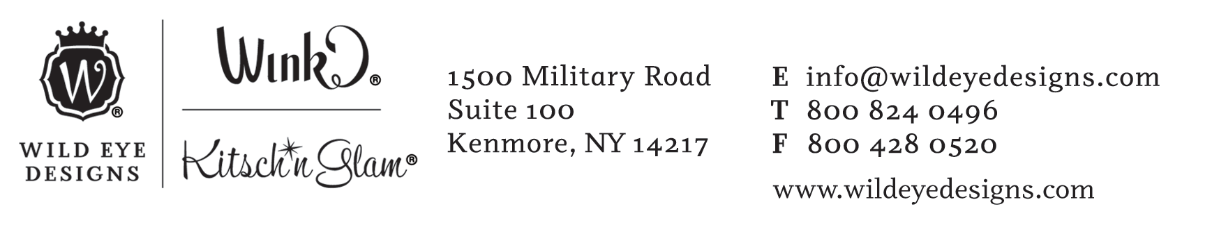
Minimum Advertised Pricing Policy Agreement
Wild Eye Designs seeks to ensure pricing integrity and to allow for fair competition on online marketplaces by setting minimum pricing levels for newer items.
MAP POLICY
The minimum advertised price for all Wild Eye Design items shall be 80% of item MSRP.
MAP and MSRP pricing is available upon request in the form of a product file.
MAP can also determined by the regular wholesale price available in our printed catalogs & on our website.
MSRP = ([Wholesale Price] + $0.01) * 2 then round up to nearest $5 and subtract $0.01
MAP = [MSRP] * 80%
Example: Bottle Openers @ $4.00 Wholesale
MSRP = $9.99
MAP = $7.99
APPLICABILITY & EXEMPTIONS:
MAP policy applies to items included in our current catalog (2018). Older or discontinued items are exempt from MAP pricing.
Policy applies to online stores and marketplaces only.
ENFORCEMENT
This MAP policy is in place as of January 2018 and by selling our products you agree to the policy. Wild Eye Designs reserves the right not to sell to resellers who do not respect MAP policy.
If you are currently in violation of our policy please correct your pricing as soon as possible. If you notice others in violation of this policy please report them to us.
Wild Eye Designs will terminate sales to online retailers who continue to violate MAP policy or show a disregard for abiding by this policy that ensures fairness for all online retailers.

